Associate Director of Finance
Candidate Brief
May 2019 | Reference ADF05/2019

About us
The Nuffield Trust is an independent health charity. We aim to improve the quality of health care and health policy in the UK by providing evidence-based research and policy analysis and informing and generating debate.

Vision
We want to help achieve a high-quality health and social care system that improves the health and care of people in the UK.
We set out to do this by:
- Improving the evidence base that leads to better care by undertaking rigorous applied research and policy analysis.
- Using our independence to provide expert commentary, analysis and scrutiny of policy and practice.
- Bringing together policy-makers, practitioners and others to develop solutions to the challenges facing the health and social care system.
- We will be grounded in the practical implications of policy-making, working closely with NHS staff and policy-makers to identify solutions. Above all, we aim to be a trusted and respected voice at a time of unprecedented challenge to the NHS and social care system.

Values
In everything we do, we strive to be:
- Independent and free from vested interests.
- Rigorous, robust and evidence-based in the work we undertake.
- Relevant, supportive but also challenging when we need to be.
- Open and engaging with all those we come into contact with.
- An organisation that makes a difference to the quality of policy-making and practice in the UK.

Current priorities
The current priorities are identified on The Nuffield Trust Website.

Funding
The Nuffield Trust is funded primarily from income generated from the Nuffield Trust’s own endowment – this helps to secure the independence of its research and wider activities.
The endowment, which is currently c£80 million, was given to the Nuffield Trust in 1940 by Viscount Nuffield. The investment income is used to fund in-house research and support its dissemination. In addition we seek grant funding and commissions from external partners for research projects that support our corporate priorities. Income generated from the endowment remains the most important source of income for the Trust, and ensures that it is not dependent on any other source of income to carry out its charitable purpose.
Annual Reports and Financial Statements are available on The Nuffield Trust Website.

Associate Director of Finance (ADF)
The former Director of Finance & Administration left the Trust in June 2018. The Chief Executive took the opportunity to review the structure of the Trust’s finance and administration function and engaged an Interim Finance Director to support the Director of Strategy & Operations both to maintain the current operations and develop future options.
The new part-time Associate Director of Finance will be employed on a rolling contract, with a view to the Deputy Director of Finance & IT (who is working through his ACCA studies) assuming the role when he qualifies in 2 or 3 years’ time. Therefore the new role of ADF is not expected to be permanent, but to last approximately 2 to 3 years.

On a day-to-day basis the Deputy Director of Finance & IT will report to the Director of Strategy & Operations, but he will have a ‘dotted line’ to the ADF who will provide him with professional leadership and technical guidance. The structure of the Operations team is as follows:

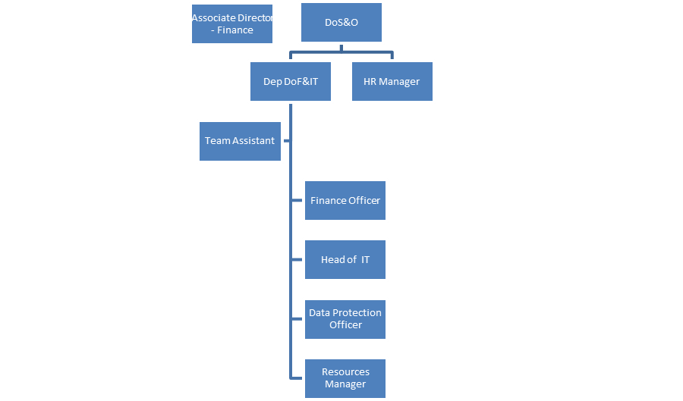

Job Description

Main responsibilities
The Associate Director of Finance role is a part time (up to 20 days per annum) post on a rolling contract.
The job description shown here is a guide and will be discussed and agreed with the post-holder on appointment.
The post-holder will assume some or all of the following principal responsibilities:
- Provide assurance to the Finance Committee and Board of Trustees on finance and investments, including reviewing and providing assurance on the annual budget, accounts and annual report, and on the quarterly management accounts before submission to the Committee and Board.

- Provide assurance to Trustees that the Deputy Director of Finance & IT is effectively:

  - Ensuring appropriate financial systems and controls are in place and are subject to continuous improvement.

  - Ensuring that the Trustees’ investment strategy is reflected in its investment portfolios.

  - Overseeing the Trust’s financial planning and budgeting process ensuring that fellow directors and their teams the support they need in devising and delivering to their budgets.

- Where required, provide an external interface with relevant regulatory bodies, banks, auditors, investment managers, insurance consultants and charity finance specialists.

- Undertake any other duties that may reasonably be required in furtherance of the objectives of the Trust.

Person Specification
The post-holder must, after reasonable training and familiarisation, be able to work on their own initiative to a high standard of accuracy and reliability. The post-holder should support the ethos of the Nuffield Trust and uphold its commitment to equality regardless of age, disability, gender reassignment, marriage and civil partnership, pregnancy and maternity, race, religion or belief, sex or sexual orientation.

Required experience
- Educated to degree level.
- Recognised accountancy qualification: ACA / CIMA / ACCA / CIPFA.
- Successful track record of leadership in a senior role with responsibility for strategic financial management and control in a charitable organisation of similar size.
- Experience of working with senior management to deliver strategic objectives and financial priorities.
- Experience of endowment management and working with investment managers, preferably with a large portfolio of investments.
- Articulate, with the ability to translate complex information for a range of audiences.
- Experience of coordinating accounting and taxation advice.
- Experience of mentoring and staff development.
- An open and honest approach along with the willingness to challenge appropriately.
- An understanding of, and commitment to, equal opportunities and cultural diversity and a willingness to support the ethos of the Nuffield Trust.

Desirable experience
- Understanding of charitable and research grants, income generation and the diversity of activities within a non-profit context.
- Understanding of the legal and governance structure around a charity. Familiarity with contract law.
- Experience of strategic leadership and management of broader support services beyond the finance function: IT, IG, property & facilities, risk, governance.
- Experience of leading change management programmes.
- Excellent Excel skills.

Health and Safety
Employees of the Trust are required to be aware of, and observe fully, the employee duties under the Health and Safety at Work Act and to observe all Nuffield Trust policies related to health and safety and risk management.

Data Protection
Disclosures of confidential information or disclosures of any data of a personal nature can result in prosecution for an offence under the Data Protection Legislation or an action for civil damages under the same Legislation in addition to any disciplinary action taken by the Trust which might include dismissal.

Equality and Diversity
The Nuffield Trust is committed to ensuring equality for its employees and job applicants and will value and respect their diversity. We recognise that everyone has a contribution to make and we will aim to ensure that all staff, Trustees, volunteers, organisations and individuals with whom we have contact will be treated fairly and in an unbiased way. The Nuffield Trust is committed to actively promoting equality and diversity and will work to address unfair treatment, discrimination and prejudice where found within the workplace and in its work. We will work within the current legislative framework to promote best practice.
To ensure the continued development of equality and diversity, all applicants are asked to provide information about how they identify themselves as part of the application process. You are not obliged to answer the questions, however, the more information you supply, the more effective our monitoring will be. If you choose not to answer any or all of the questions, it will not affect your application. Any information you do supply is kept strictly confidential and will be used solely for monitoring purposes. The selection panel will not see this information.

Terms of Appointment
This is a part time (up to 20 days per annum) appointment based in London.
The remuneration for this position is c.£850 per day, dependent on the background and experience of the chosen candidate.
The appointment will be subject to receipt of two satisfactory references and evidence of right to work in the UK.

Application and Selection Process
Candidates wishing to apply should submit a detailed CV and complete the Trust’s Application Form via the online web portal.

Any queries should be directed to
Email: recruitment@nuffieldtrust.org.uk
Telephone: Human Resources on 020 7631 8450.

The closing date for applications is midnight Sunday 16 June 2019.

Applications will be reviewed on receipt and interviews scheduled accordingly. We reserve the right to close the application process early should an appointment be made.

